## horizontal line

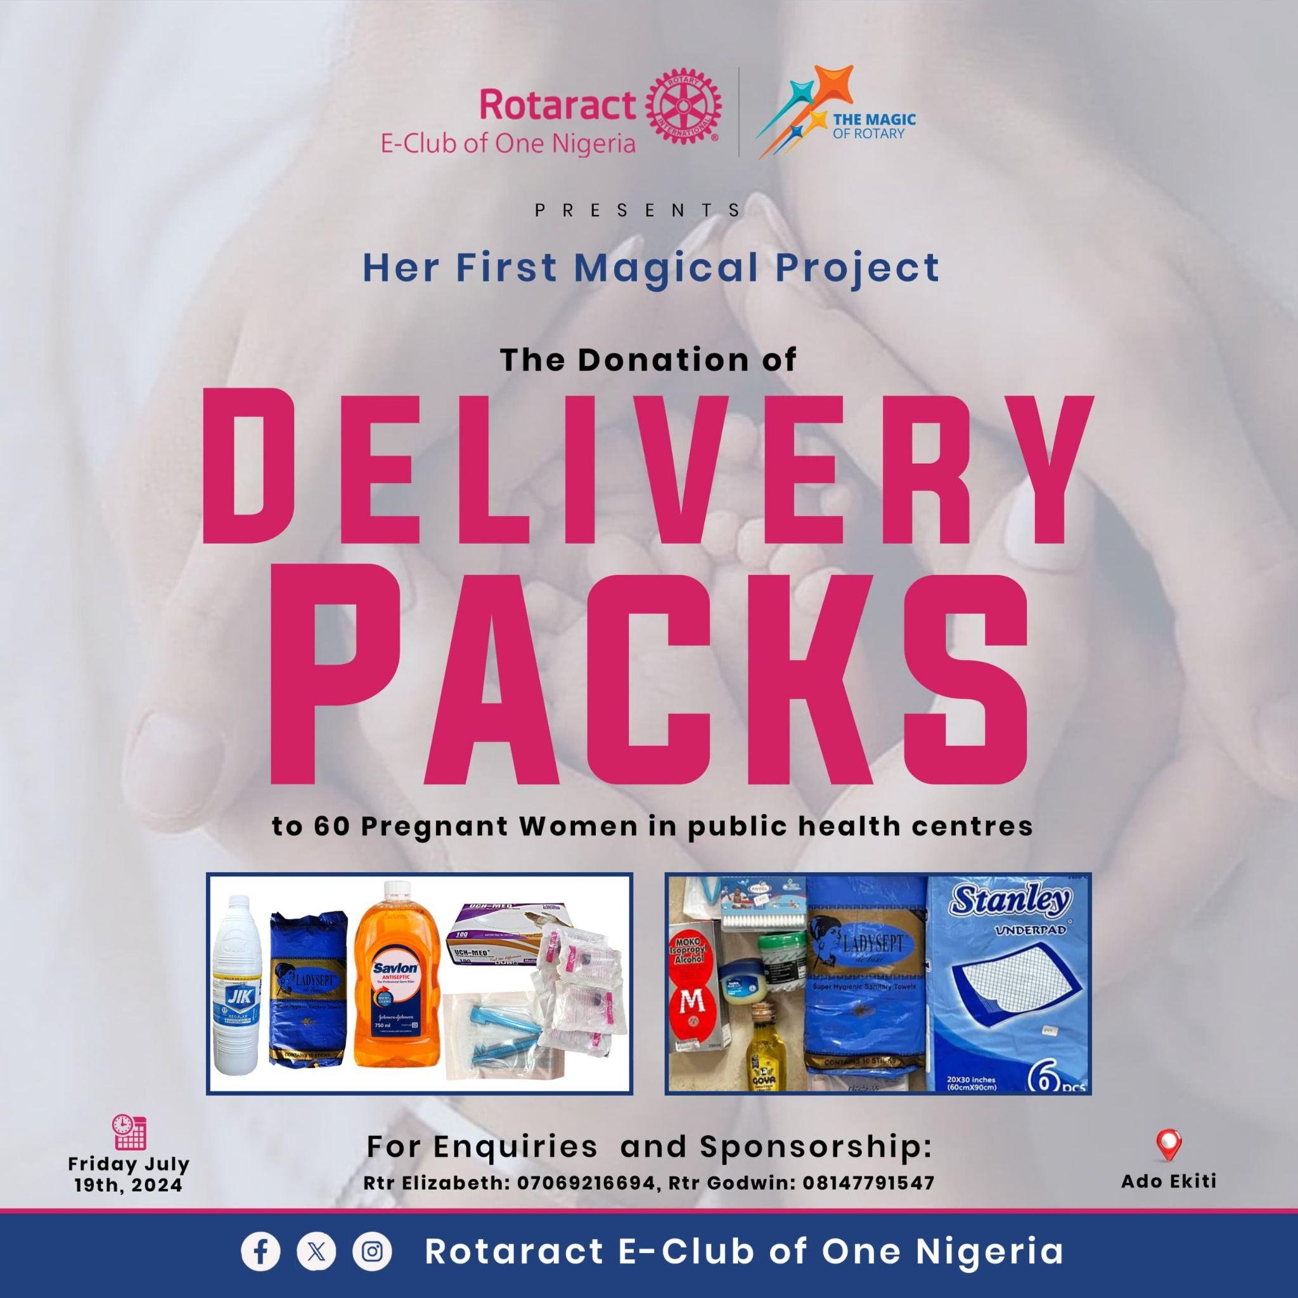

DONATION OF DELIVERY PACKS

HER FIRST MAGICAL PROJECT

**─**

RTR. AKINLOLU ELIZABETH F.

Vice President / Project Director

Rotaract E-club of One Nigeria

# Overview

The Rotaract E-Club of One Nigeria presents her first magical project as a chartered Rotaract club which is **“THE DONATION OF DELIVERY PACKS TO 60 PREGNANT WOMEN IN PUBLIC HEALTH CENTERS IN ADO-EKITI, EKITI STATE”** scheduled to take place on Friday July 19th, 2024. This project was birthed in compliance with the Rotary calendar for which the theme for the month of July is “MATERNAL AND CHILD HEALTH MONTH”.

For the successful completion of this project, certain items that are expected of them to already have at the time of delivery will be packed in a Rotaract customized nylon and handed over to each of these women that must have been chosen and proved eligible for the package by the public health nurses or midwives in the chosen public health centers.

# Goals

1. To provide an opportunity for underprivileged pregnant women to have the basic things they need while going into the labor ward for smooth and comfortable delivery for both midwife, mother and child with aseptic techniques.
2. To support them emotionally and financially thereby reducing mental stress/depression that could cause certain complications in pregnancy like Preeclampsia and PIH (Pregnancy Induced Hypertension) to mention a few.
3. To provide an opportunity for us to serve humanity.
4. To encourage and motivate young people for eventual membership in Rotaract.

# Specifications

## BUDGET

Each pack will contain

* Underlay
* Perineal Pad
* Cord Clamp
* Mucus Extractor
* Mackintosh
* Surgical gloves
* Latex gloves
* Savlon (smallest size)
* Goya Oil
* Methylated Spirit

|  | **ITEMS** | **PRICE (₦)** | **QUANTITY** | **TOTAL (₦)** |
| --- | --- | --- | --- | --- |
| 1. | Underlay | 500 | 3 pieces | 1,500 |
| 2. | Perineal Pad | 1,200 | 1 pack | 1,200 |
| 3. | Cord Clamp | 100 | 1 piece | 100 |
| 4. | Mucus Extractor |  |  |  |
| 5. | Mackintosh | 1,500 | 1 yard | 1,500 |
| 6. | Surgical Gloves | 300 | 2 pieces | 600 |
| 7. | Latex Gloves | 4,000 | 1 pack | 4,000 |
| 8. | Savlon | 3,000 | 1 bottle | 3,000 |
| 9. | Goya Oil |  |  |  |
| 10. | Methylated Spirit |  |  |  |
| 11. | Customized nylon | 12,000 | 100 pieces | 12,000 |
|  | **GRAND TOTAL** |  | 60 packs |  |